Geagte ouer/voog die volgende werk is vir ‘n tydperk van twee weke so gebruik asb u eie oordeel oor hoeveel werk op ‘n dag gedoen moet word.

Wees asb geduldig met die leerders en onthou hulle kort u hulp hulle kan nog nie die werk op hulle eie doen nie.

Dankie vir al u hulp ons hoop om al ons pragtige kinders gou weer in die klaskamer te sien.

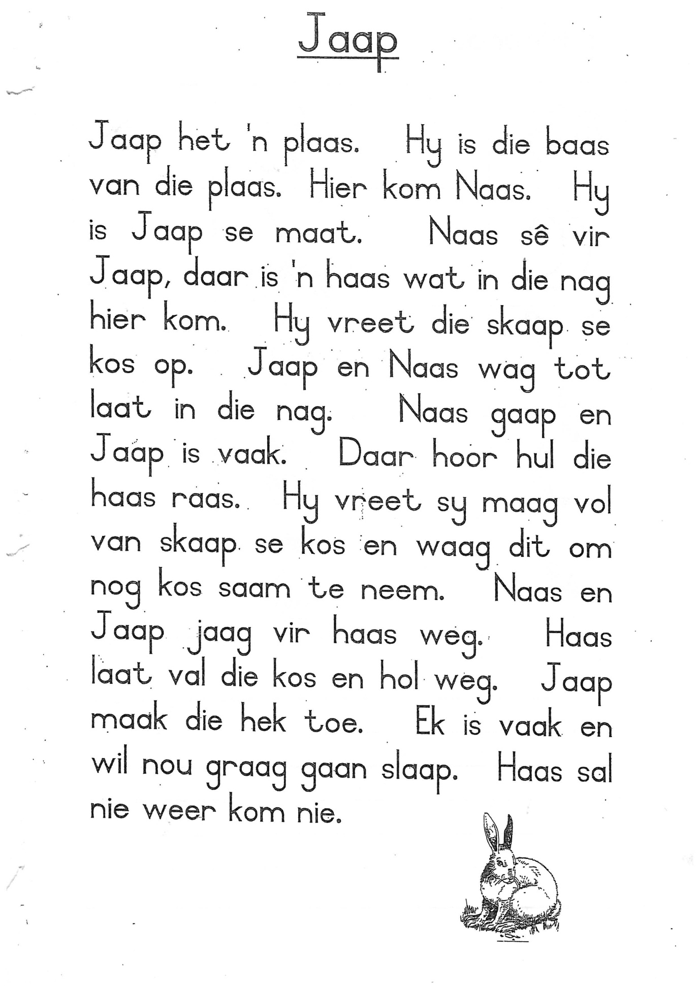

**Lees die storie saam met die leerder en dan moet leerder al die aa klanke omkring.**

aa Woorde

Met hulp van ouer/voog skryf die woord wat by elke prent pas.

|  |  |  |  |
| --- | --- | --- | --- |
| [https://lh3.googleusercontent.com/rYcYZZ1HKcjA8a4PJcRlIEZtjG4hs3OwcZJhAMwQ34T9ZwRPDnwyrCfPjcdmoSyUaUBmtA=s108](https://www.google.co.za/search?sa=G&hl=en-ZA&q=colouring+picture+of+cheese&tbm=isch&tbs=simg:CAQSlgEJ3o1MZAZSY9EaigELEKjU2AQaBAgUCAoMCxCwjKcIGmEKXwgDEifCCNgd6RNf1BPrE9cd6hOhBr0Hxie7J_1U91jbXNsMntjTdNpg1lzUaMFNOUa72QQtnG6NOydgnWyfTBs2KWbGkigXa5sIcIb0DE785qiMpLeFomTJBM17fjCAEDAsQjq7-CBoKCggIARIEJWADWgw&ved=0ahUKEwj1uvyzwcHcAhVTdcAKHUBGB2YQwg4IJSgA) |  | [https://lh3.googleusercontent.com/ZMzzscpchfqas5d3yyt5K_hyC5mEnSJGtjD83HmOK4GpzC2LbQSAa1bzZuIL_xpboOyt=s85](https://www.google.co.za/search?sa=G&hl=en-ZA&q=Vector+graphics&tbm=isch&tbs=simg:CAQSlwEJerAH49K1aBMaiwELEKjU2AQaBAgUCAoMCxCwjKcIGmIKYAgDEiiBFMIIwBSeBoIUwwibA-sT-gnsE74kiiqWJLIg8CmHKok4yCmnLeEsGjCLJ5oMRhHxn-aonZKJXFuNxb_1phZ1PktJf8UyjGtlm80VmB03Y6z-Bj8yVOnm-KZEgBAwLEI6u_1ggaCgoICAESBBMoisoM&ved=0ahUKEwiA9eSlw8HcAhXLKcAKHVxrAysQwg4IJSgA) |  |
| [https://lh3.googleusercontent.com/J8swpRIVvHSS7eKLpqrm81uewDX4l3-sjzUBk3pTqrcDvCcc3ovJv_gnYn4GWFOdEL-MAg=s85](https://www.google.co.za/search?sa=G&hl=en-ZA&q=%E6%9C%88%E4%BA%AE+%E6%8F%92%E5%9C%96&tbm=isch&tbs=simg:CAQSlwEJzRqke3gCsVYaiwELEKjU2AQaBAgUCAoMCxCwjKcIGmIKYAgDEii9B8IIvAfYHekToQaDA9cdmwPUE5UklzWWJKQ0qDThLIYqiiqJOKc0GjDprvxHRfVxqEyoqdU5P-wj-hHuvN2a72IKNnrQHjmB89i0BTDVfp-tjO2GmaITZY8gBAwLEI6u_1ggaCgoICAESBMqAuFYM&ved=0ahUKEwj2kdyUwsHcAhXFX8AKHSrJBAoQwg4IJSgA) |  | [Image result for black line drawing of  a round wooden  pole](http://www.nzdl.org/gsdlmod?e=d-00000-00---off-0cdl--00-0----0-10-0---0---0direct-10---4-------0-1l--11-en-50---20-help---00-0-1-00-0--4----0-0-11-10-0utfZz-8-00&cl=CL2.5&d=HASH01e340617b4802fce415c5a5&gt=2) |  |
| [https://lh3.googleusercontent.com/W369oJm74HjTFIgJ5Qrbgd2yzo22UiiroP53WSiaWwM_wPugei4sGIVuxT82OPJzxJHXLg=s85](https://www.google.co.za/search?sa=G&hl=en-ZA&q=clip+art&tbm=isch&tbs=simg:CAQSlwEJqRtqUHFXnIgaiwELEKjU2AQaBAgUCAoMCxCwjKcIGmIKYAgDEijXHbwHuwfNE9QT-B_1YHc8TuAfDCOEssCOnLYcqlzWnNIYqxieeI4UqGjCSHX4URhEBeWnEou94mLBpCOFl9kyZvWMfsv47wrx8f0XQ8NPAaCAhZXXxaO6jXYEgBAwLEI6u_1ggaCgoICAESBH9ct_10M&ved=0ahUKEwjelabLwsHcAhVrBcAKHV4ZD6UQwg4IJSgA) |  | [https://lh3.googleusercontent.com/7IFLO-9Kpn0Tbn0hZN0DtKRvblGO0KbfdJeaGbgyFnNSG675fVlwXzZDZey_QLeiy1Wg=s91](https://www.google.co.za/search?sa=G&hl=en-ZA&q=water+faucet&tbm=isch&tbs=simg:CAQSlwEJpGLj7w0miJcaiwELEKjU2AQaBAgUCAoMCxCwjKcIGmIKYAgDEijYHdQTwgiDA70H1x3rE-kT-B_1qE8YnmDWUPqc0wCeMOJQnxTeJOJc1GjAjN2xEElkBqZaoFYCXTSWy0f4x-omuZ2QIAiqJxjwHIFvUuAq875dqeV3h6wNH5W0gBAwLEI6u_1ggaCgoICAESBNaigj0M&ved=0ahUKEwiLtb7GzsHcAhUsIcAKHfVAA7UQwg4IJSgA) |  |
| [Image result for black line drawing of  a frame](https://www.pinterest.com/pin/314970567672860231/) |  | https://lh3.googleusercontent.com/0PQt62JZnNkWM_uXMIBQiqGKh-qkbCyKRJgSj0C8nk_F0k6OrujUuhkTgK-uuyHXy9ziKFA=s85 |  |
| [Image result for black line drawing of  a wheat ear](http://getdrawings.com/ear-of-corn-drawing) |  | [[Image result for black line drawing of  a vase](https://www.google.co.za/imgres?imgurl=https://publicdomainvectors.org/photos/Vase14Line.png&imgrefurl=https://publicdomainvectors.org/en/free-clipart/Outlined-vase-drawing/62456.html&docid=IdEw7-Jh09EhjM&tbnid=vs50t8d9LmAiZM:&vet=10ahUKEwi298WPz8HcAhVhIMAKHbzjC40QMwhdKB4wHg..i&w=262&h=500&bih=974&biw=1920&q=black%20line%20drawing%20of%20%20a%20vase&ved=0ahUKEwi298WPz8HcAhVhIMAKHbzjC40QMwhdKB4wHg&iact=mrc&uact=8)262 × 500 - publicdomainvectors.org](https://www.google.co.za/imgres?imgurl=https%3A%2F%2Fpublicdomainvectors.org%2Fphotos%2FVase14Line.png&imgrefurl=https%3A%2F%2Fpublicdomainvectors.org%2Fen%2Ffree-clipart%2FOutlined-vase-drawing%2F62456.html&docid=IdEw7-Jh09EhjM&tbnid=vs50t8d9LmAiZM%3A&vet=10ahUKEwi298WPz8HcAhVhIMAKHbzjC40QMwhdKB4wHg..i&w=262&h=500&bih=974&biw=1920&q=black%20line%20drawing%20of%20%20a%20vase&ved=0ahUKEwi298WPz8HcAhVhIMAKHbzjC40QMwhdKB4wHg&iact=mrc&uact=8) |  |

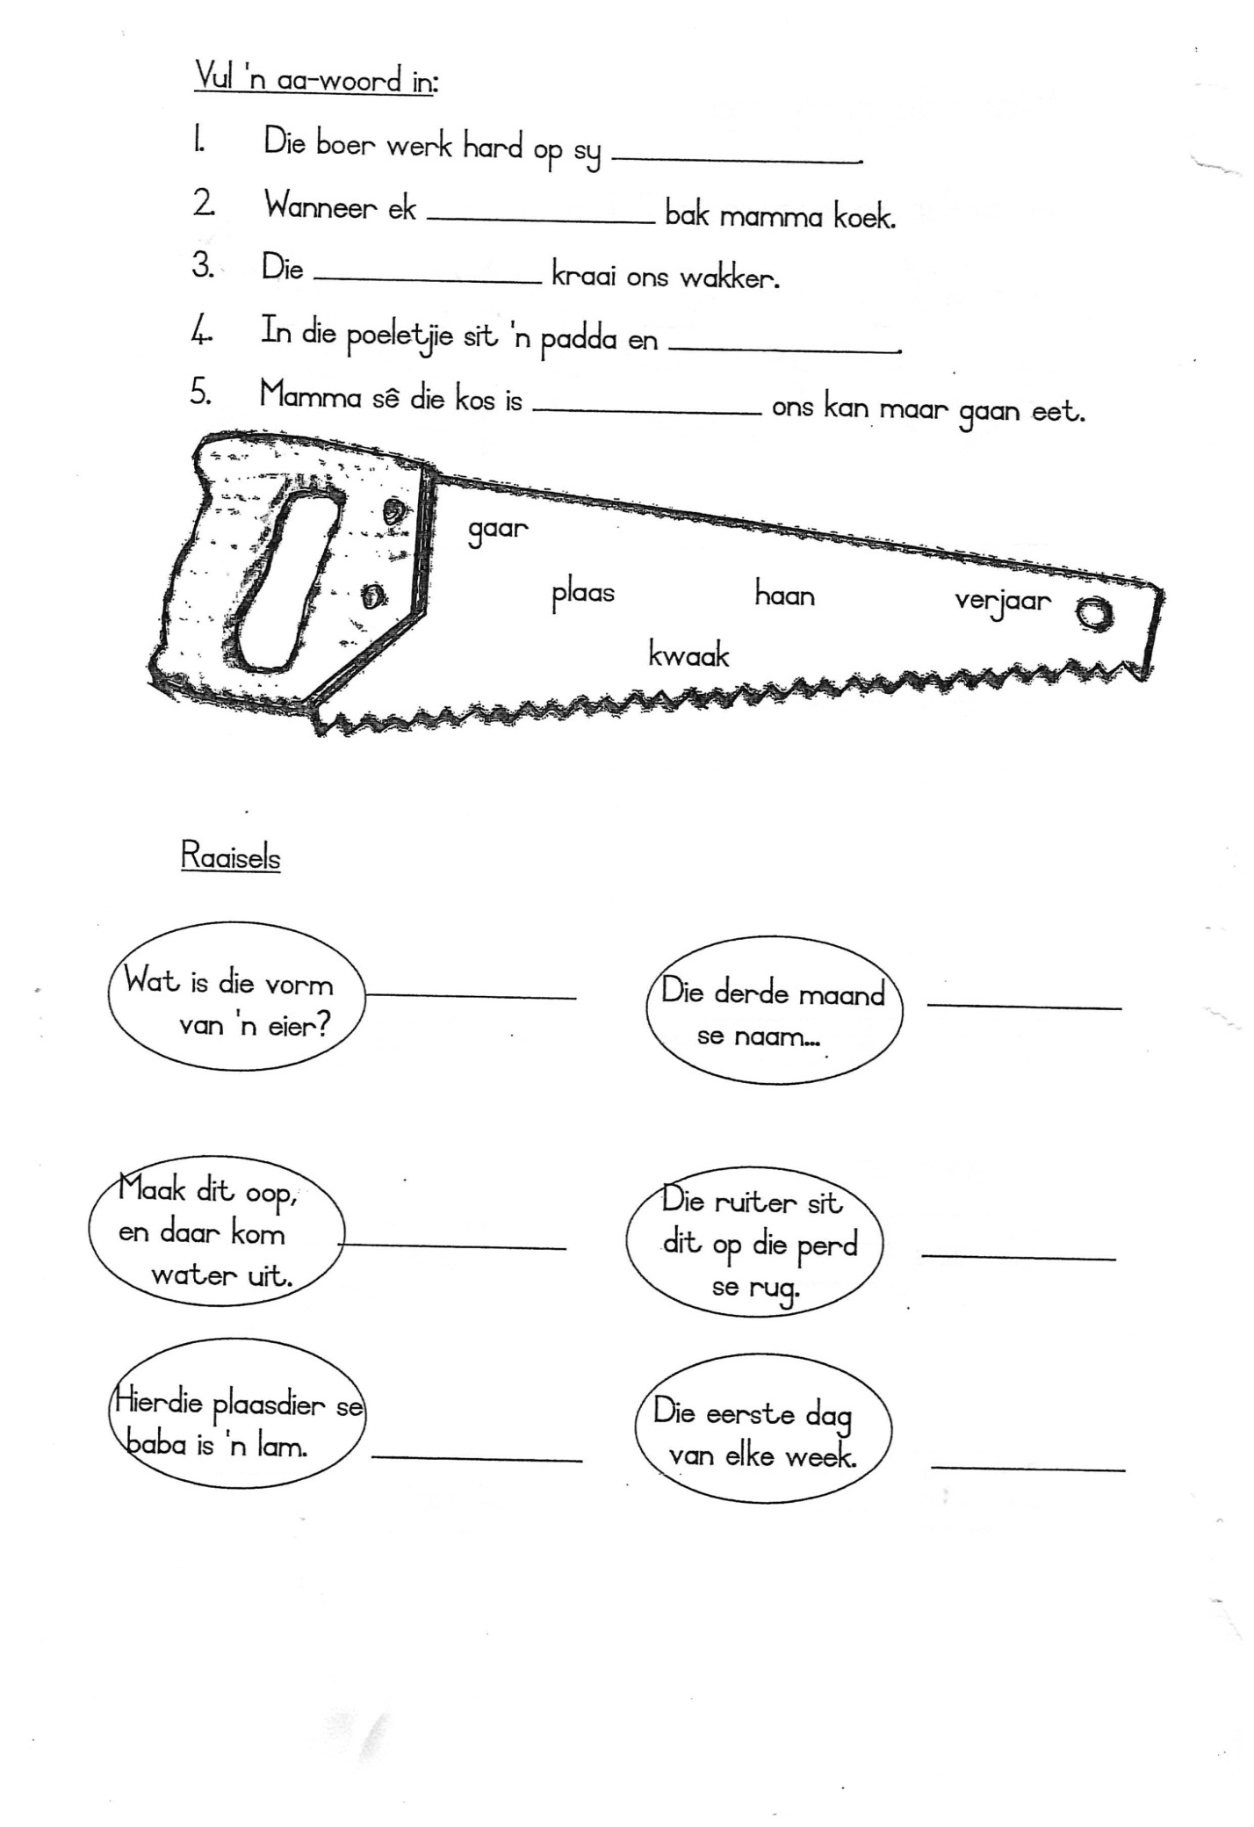

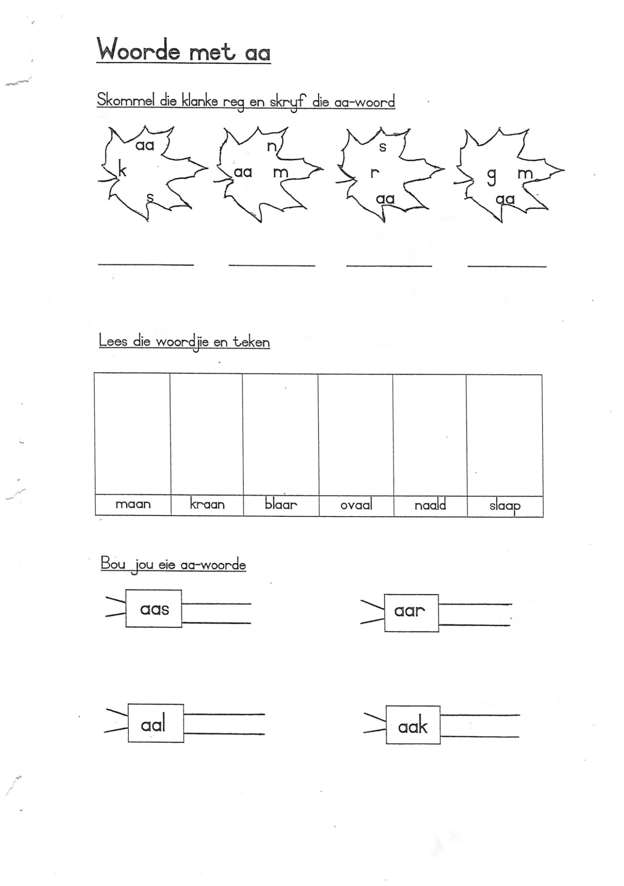

Naam: Woordbou a-klank Datum:

Omkring die a-woord wat by die prentjie pas:

|  |  |  |  |  |  |
| --- | --- | --- | --- | --- | --- |
| http://www.artimpressions.com/Images/Big/E2715.jpg | small-house-in-the-village-coloring-page.jpg | http://3.bp.blogspot.com/_v_vwfBKnpuc/TLHGA9O0HRI/AAAAAAAAAO0/VOjQhIt7vWA/s200/001554_Comb.gif | A black and white illustration of a frying pan | http://www.sundayschoolresources.com/images/cptmoon1.gif | http://www.dmuuc.org/virtual_memorials/Wilcox/SailBoat.gif |
| bak  bal  bas | dam  das  dak | kas  kam  kat | pas  pan  pad | nag  nar  nat | mas  man  mak |

Kyk na die prentjies en skryf elkeen se naam onderaan:

|  |  |  |  |  |  |
| --- | --- | --- | --- | --- | --- |
| [Clown's Face](http://www.supercoloring.com/pages/clowns-face/) | Branch2_sm | http://enews.toxicslink.org/im-info/plastic_bag.jpg | [baby kitten coloring page](http://www.cool-kids-craft-ideas.com/image-files/color-cat5.gif) | Little Lamb color page | face man round |
|  |  |  |  |  |  |

|  |  |  |  |  |  |
| --- | --- | --- | --- | --- | --- |
| free printable coloring image Book Bag 14 | Car coloring pages | Mens Clip On Neck Tie | http://ngfl.northumberland.gov.uk/clipart/Food/images/mixing%20bowl_jpg.jpg | Early American Society Coloring Page | A black and white illustration of a frying pan |
|  |  |  |  |  |  |

**Geagte ouer/voog lees die storie vir die leerder 3 keer en dan moet die leerder die antwoorde verbaal beantwoord.**

[[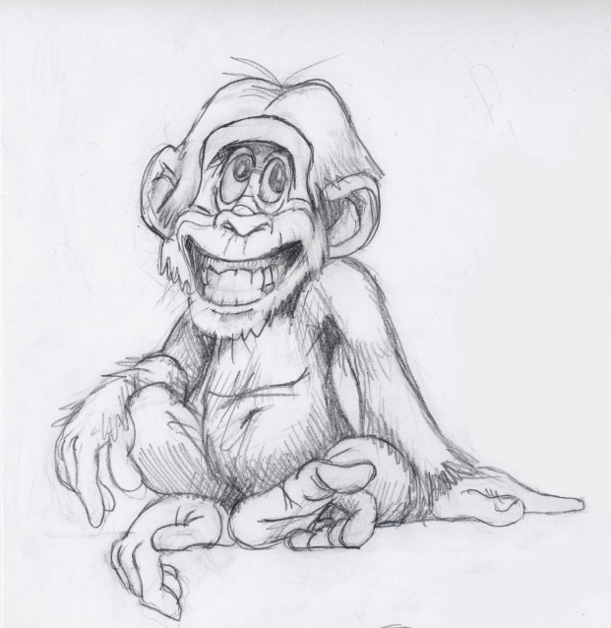](https://drawingartpedia.co/realistic-monkey-drawing/realistic-monkey-drawing-blackbook-monkey-madness/)](http://www.pioneervalleybooks.com/pawprints-resources)**[Die jonge Apie](http://www.pioneervalleybooks.com/pawprints-resources)**

In die oerwoud woon daar ‘n apie met

die naam Japie. Hy is altyd vol grappe

en skelm streke. As hy nie besig is om

Papegaai se bessies weg te steek nie,

is hy besig om Leeu se maanhare te vleg,

of iewers poetse te bak!

Die diere in die woud is al moeg vir Japie se skelm streke en besluit om ‘n plan met hom te maak. Hulle nooi toe almal uit na ‘n vergadering om te besluit wat hulle met hierdie lawwe apie gaan doen. Na ‘n lang bespreking besluit hulle om vir Japie aan te wys as die woud se eie nar.

Saam met Japie se nuwe posisie, as Oerwoudnar, het daar ook ‘n paar reëls gekom. As nar, mag hy slegs soos ‘n nar optree by verjaardagpartytjies en feeste. Hy mag ook nie enige nar-streke uithaal op roofdiere of slapende diere nie.

Japie het ingestem om die woud se nuwe nar te wees en het gereeld die diere laat rol van die lag.

Begrip:

Antwoord die volgende vrae nadat jy die stuk op die vorige

bladsy gelees het.

1. Waarom het die diere in die woud nie van die apie gehou nie?

2. Watter skelm streke het hy aangevang?

3. Wat dink jy sou gebeur het as die diere nie ‘n plan gemaak

het nie?

4. Noem die nuwe reëls wat saam met sy posisie gekom het.

[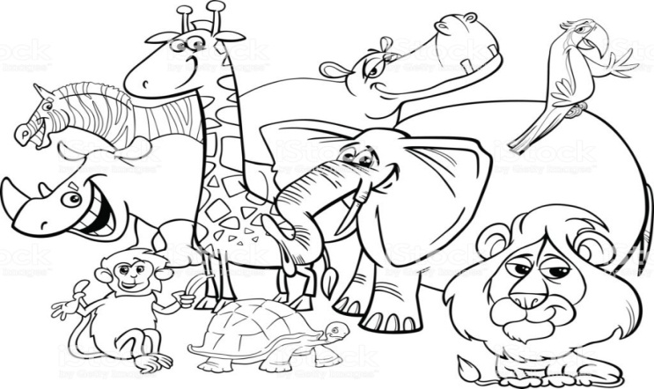](https://www.istockphoto.com/ca/illustrations/black-and-white-animals)5. Hoekom moes Japie nie die roofdiere pla nie?

Help vir Bennie om die volgende woorde by die regte prentjies te kry:

|  |  |
| --- | --- |
| Oupa lees ‘n boek | d:\pfiles\msoffice\clipart\standard\stddir1\BD06468_.WMF |
| die muis | d:\pfiles\msoffice\clipart\standard\stddir3\NA00626_.wmf |
| Bennie se huis | d:\pfiles\msoffice\clipart\standard\stddir1\AN04317_.WMF |
| Linda se pop | d:\pfiles\msoffice\clipart\standard\stddir1\AN01709_.wmf |
| die kat Wollie | d:\pfiles\msoffice\clipart\standard\stddir2\BD07840_.WMF |
| ‘n boom | C:\Program Files\Microsoft Office\Clipart\Pub60Cor\SO00289_.wmf |
| drie balle | d:\pfiles\msoffice\clipart\standard\stddir4\PE02634_.wmf |
| die paashaas | d:\pfiles\msoffice\clipart\standard\stddir3\HH01215_.wmf |