PART 3

Liewe graad 4 maats
Hierdie 5 weke was nou heeltemal te lank. Ek verlang na elkeen van julle en kan nie meer wag om julle te sien nie. Ek glo elkeen van julle doen julle bes met julle skoolwerkies. Ek weet sommer ek gaan baie trots wees op die spogwerk!
Sien julle sommer binnekort!
Liefde Juffrou Dane’

Geagte Graad 4 ouer(s)/voog(de)
Ek wil vir elke ouer ‘n besondere dankie sê vir julle harde werk en opoffering rakende die kinders se skoolwerk. Saam is ons ‘n span en sal ons hierdie uitdaging oorwin want niks sal ons kan onder kry nie. Julle is TOPS!!
Groete
Mej D. Oosthuizen

ONTHOU:
Om te verseker dat die leerders op datum bly met al die werk gaan ek ‘n paar weke se werk deurgee. Die leerders is in besit van hulle handboeke maar omdat hulle skrifte ingeneem is sal hulle die werk op ‘n ander bladsy moet voltooi. Ek vra asb dat die bladsye mooi gemerk moet word met u kind se naam, van en graad op. Hierdie bladsye moet in die leerder se skrif geplak word, daarom moet die leerder net aan die een kant van die bladsy skryf. Let asb op na die formaat van die opskrifte, datums (word in potlood geskryf) en kleure. Leerders skryf alles in blou pen behalwe as ek ‘n kleur gebruik of ander instruksies gee.
BAIE DANKIE!

Date
Writing and presenting
Activity 4a-b p76-77
Xxx
1. Learners own answer
2. Learners own answer
3.
4. a) Milk, chocolate powder
b) a glass and a spoon
c) He must stir it into the milk.
xxx
Activity 4b
Xxx
(copy/print this table and complete)
Ingredients | Utensils
- Bread | - Knife
- Butter | - Cutting board
- Jam
xxx
Instructions Learners own answer.
Xxx
___________________________________________________________________________

Date
Language
Activity 5 p77
Xxx
- A) can
b) must
c) will
d) must
e) must
xxx
_________________________________________________________________________
Date
Language
Activity 6 p. 78
Xxx
(Feel free to print and past in, but a copy will be provided once school opens.)

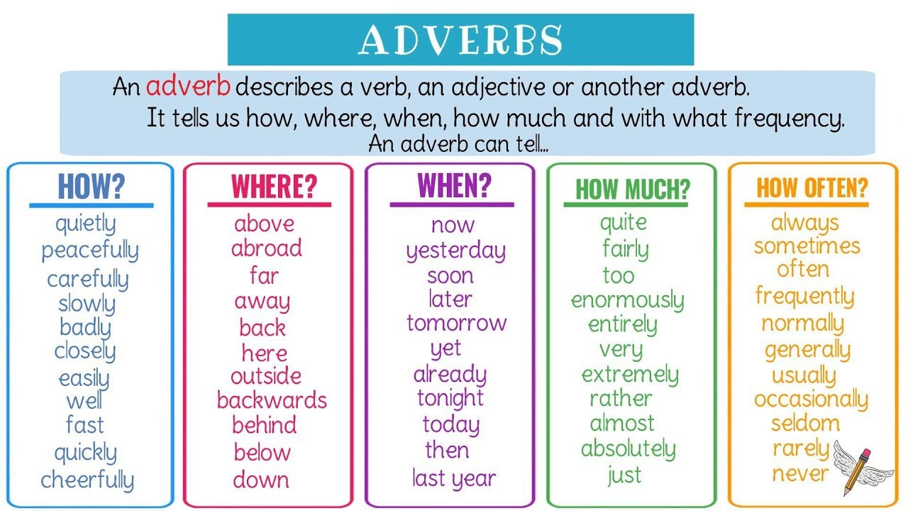

Adverb of manner: The children played peacefully.
Adverb of place: I’ve lived here for about two years.
Adverb of time: Today will be a sunny day.
Adverb of degree: I will rather have some water.
Adverb of frequency: It’s always cold in this room.

- (copy the whole paragraph and fill the words in with your green pen.)
Vusi carefully stirred the boiling porridge. Then he slowly poured it into his bowl. He sprinkled sugar everywhere. He was hungry so he ate greedily.
Xxx
___________________________________________________________________
Date
Language
Activity 7 p78
Xxx
(copy the following words and write the antonym for each word with your green pen)
- dry- wet
here- there
up- down
warm- cold
many- few
ask- answer
tasty- tasteless
deep- shallow
near- far
slowly- quickly
xxx
_________________________________________________________________________
Date
Reading and viewing
Activity 8 a-b p 79-80
Xxx
- a) Tomato
b) Tomatoes, sugar, white vinegar, salt, spices
c) On chips etc.
d) Lesotho
e) 700 ml
xxx
NEW PAGE

Activity 8b p80
Xxx
Planning ( Pencil- Copy this mind map and complete the details)
Xxx
(Instructions is on page 172- Text 9b: Chapter 9 Make a label) Learners own.

Xxx
Draft (Pencil- Follow the instructions)
13 cm x 13 cm

Edit
Edited by _______________________
xxxx
Final ( Use colour)
13 cm x 13 cm

Xxx
______________________________________________________________________
Date
Reading and viewing
Activity 9 p81
Xxx
Pre- reading
Xxx
1. Learners own answer.
Xxx

Vocabulary
Xxx
- (2 words)
Xxx
Post reading
Xxx
- a) Box, foil, black paint, newspaper, stick
b) sun’s heat
c) Reflected heat (sliver), absorbed heat (black paint), newspaper
d) Uses renewable (sun’s) energy

xxx
_________________________________________________________________________
Date
Language
Xxx
(copy)
Command verbs:
These are used to give orders or instructions.

Xxx
(Copy this sentences and underline with your green)
Xxx
__________________________________________________________________________

Date
Language
Xxx (copy)
Modal verbs:
Modal verbs are a very important of the English language. Modal verb are used with other verbs to express various things like ability, obligation and possibility

Xxx
(copy and underline with your green)

Xxx______________________________________________________________________
Date
Language
(Page 81 in DBE book.)
Do the whole page. Cut out and past in.
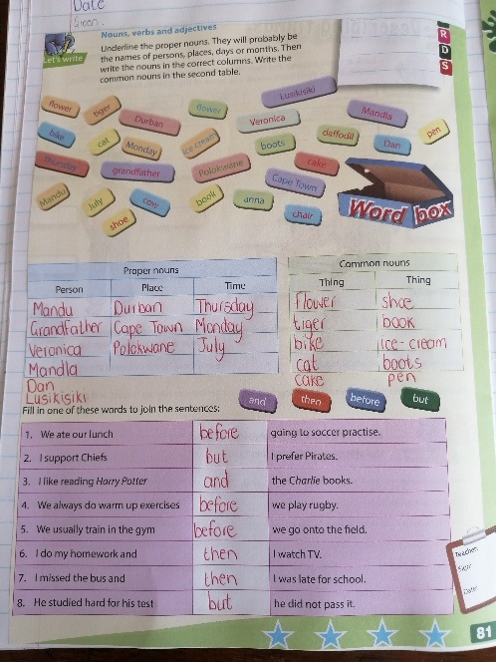

Xxx
______________________________________________________________________
Date
Language
(Page 110-111 in DBE book.)

Page 110: Only The blue block (Adverbs of degree). Cut out and past in.
Page 111: Whole page. Cut out and past in.
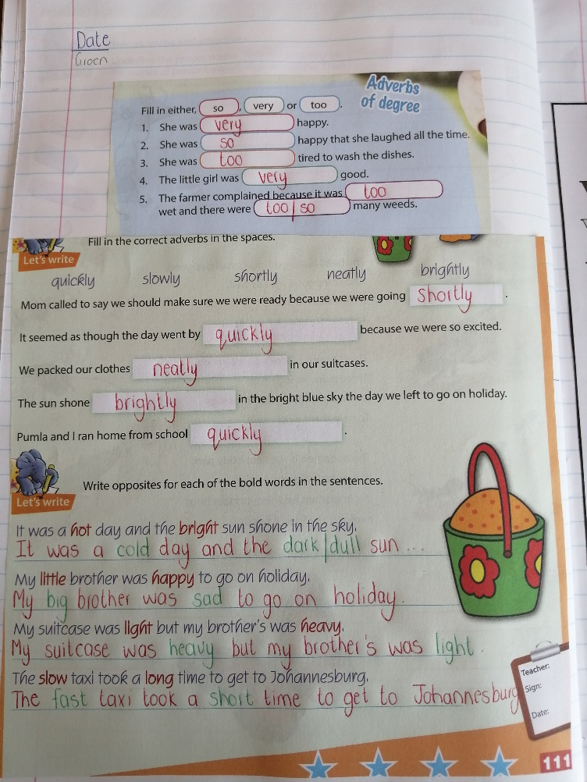
Date
Writing and presenting
Xxx
(Feel free to print and past in, but a copy will be provided once school opens.)

Xxx Learners own answer
Page 36 and 39 in DBE book.
Story on page 36: Read the story.
Page 39: Summarize the story.
Xxx
_________________________________________________________________________

