PART

Geagte Graad 4 ouer(s)/voog(de)
Om te verseker dat die leerders op datum bly met al die werk gaan ek ‘n paar weke se werk deurgee. Die leerders is in besit van hulle handboeke maar omdat hulle skrifte ingeneem is sal hulle die werk op ‘n ander bladsy moet voltooi. Ek vra asb dat die bladsye mooi gemerk moet word met u kind se naam, van en graad op. Hierdie bladsye moet in die leerder se skrif geplak word, daarom moet die leerder net aan die een kant van die bladsy skryf. Let asb op na die formaat van die opskrifte, datums (word in potlood geskryf) en kleure. Leerders skryf alles in blou pen behalwe as ek ‘n kleur gebruik of ander instruksies gee.
Voorspoed vir kwartaal 2.
Groet D. Oosthuizen

Date
Language
Tenses
Xxx
(Feel free to print and past in, but a copy will be provided once school opens.)
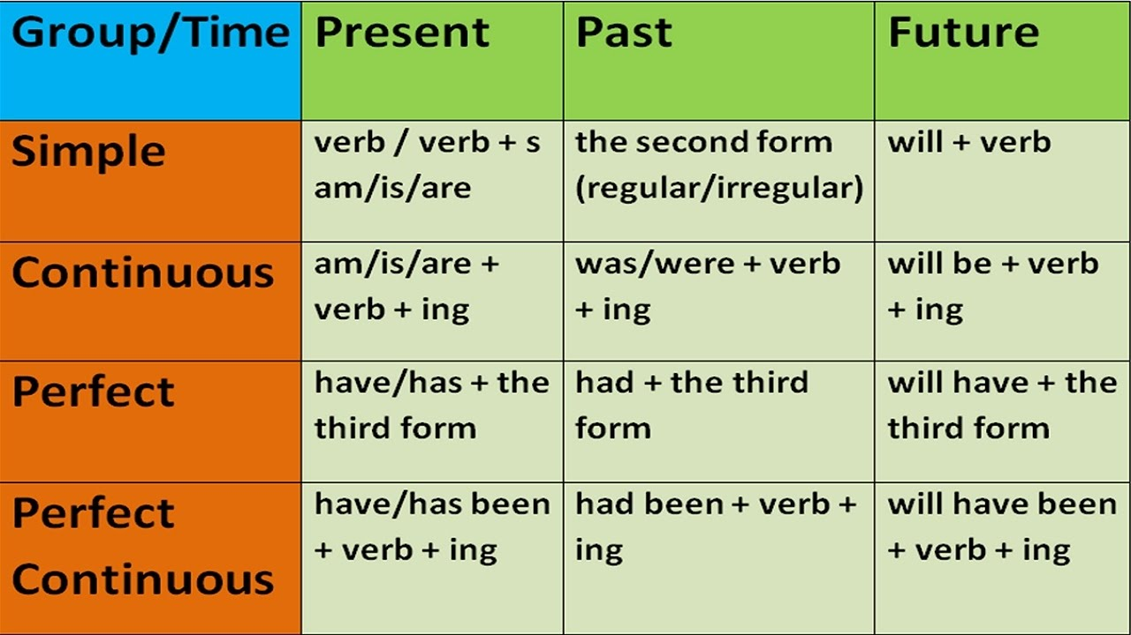

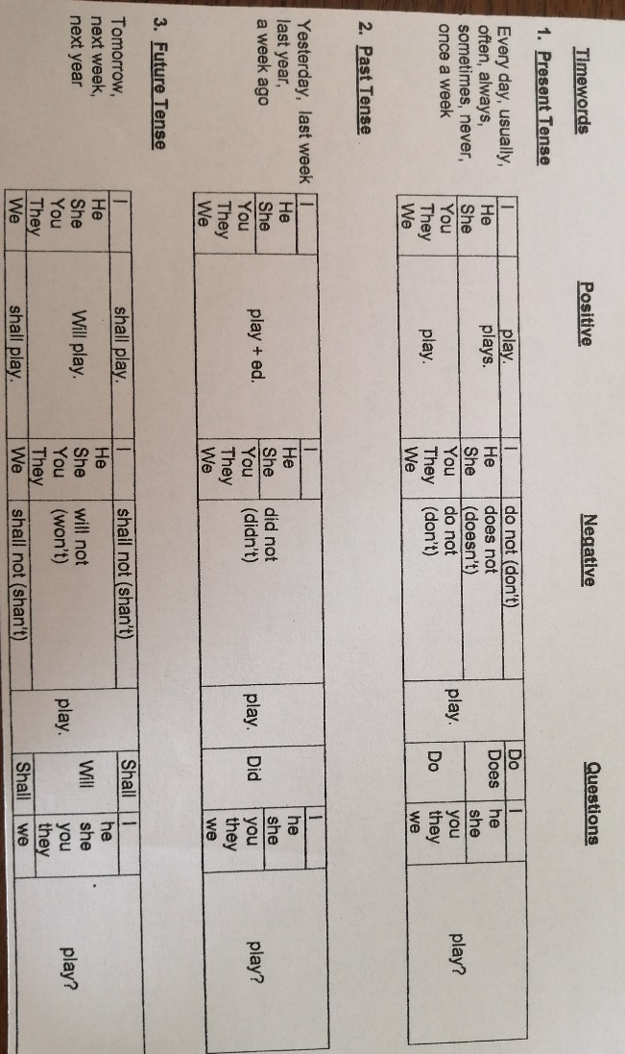

Xxx

Learners can do the following activities in their pink DBE books.

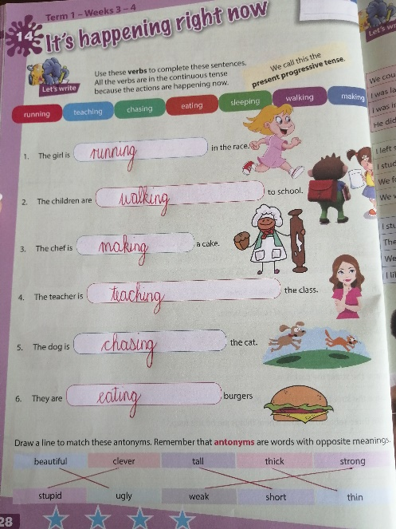
P 28 – present progressive tense: cut out and past in workbook.

P 31- Purple block: cut out and past in workbook. Learners own answer.
P 62- Bottom: cut out and past in workbook.
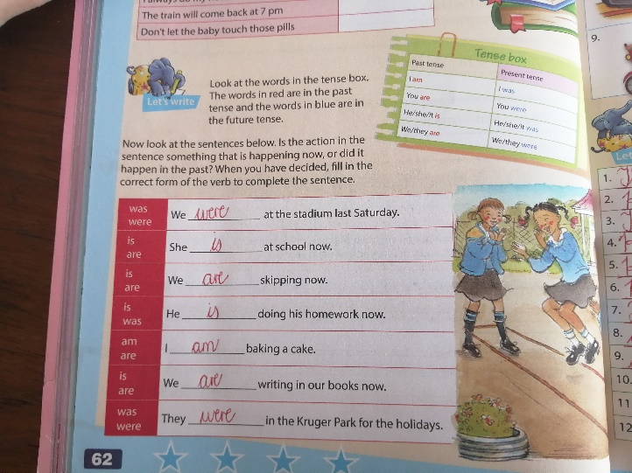
P 63- Bottom: Cut out and past in workbook.
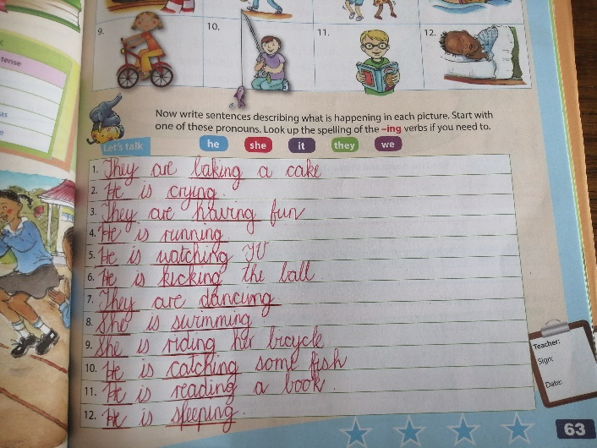
P 100- Cut out and past in workbook.
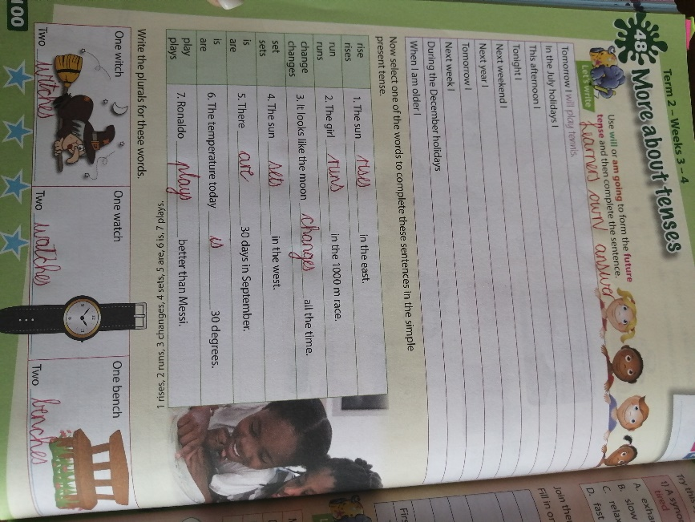
Xxx
Date
Listening and speaking
Activity 1 p 65
Xxx
Pre- listening
Xxx
What is a fable?
A short story with animals as characters to teach a moral lesson.
Xxx
Vocabulary
Xxx
(2 words)
Xxx
Post listening
Xxx
2.a) In the summer, Grasshopper hopped about in the field but Ant collected food.
b) Then in the winter, Grasshopper has nothing to eat but Ant had plenty.
xxx
3. learners own answer
xxx
4. Learners own answer.
Xxx
5. This is a fable because it teaches us a lesson/ because the animals behaved like humans.
Xxx
6. The moral of the story is that you should plan ahead/ you should work while you can.
Date
Reading and viewing
Activity 2a+b p66-67
Xxx
2a: Pre- reading
Xxx
- A)
b) learners answer.
2. Learners own answer.
3. Learners own answer.
Xxx
(Read the story. Second time learner must read with you.)
2b: Vocabulary
Xxx
(2 words)
Xxx
2c: Post reading
Xxx
2. Fox and Goat
3. a) In a well
b) Fox
c) Goat
d) Is the water good down there, Fox?
e) First he will climb on Goat, then he will get out of the well.
xxx
__________________________________________________________________________
Date
Writing and presenting
Activity 4 p69
Xxx
(copy the frame on p69. Use the story on p 66 to complete.) Learners own story.
Xxx
__________________________________________________________________________
Date
Reading and viewing
Activity 6a-d p 70-71
Xxx
6a: Pre- reading
Xxx
- (write down) Learners own answer.
Xxx
(Read the story. Second time learner must read with you.)
6b: Vocabulary
Xxx
2 words
Xxx

6c-d: Post reading
Xxx
1.a) Animals
b) Yes, because/ No, because…
c) Leeds, seeds, weeds, mean, green
d) Sue, zoo, flew, blue
xxx
Activity 6 d
Xxx
- cat
cow
dog
spoon
Xxx
2.
Xxx
3. Learners own answer.
Xxx
__________________________________________________________________________

Date
Activity 7 p72
Xxx Learners own.
2.
15 lines

Xxxx
________________________________________________________________________

Date
Listening and speaking
Activity 1 p 73
Xxx
Pre- listening
Xxx
When you hear the word supper, what do you think about? (write down your answer) Learners own answer.
Xxx
Vocabulary
Xxx
(2 words)
Xxx
Post listening
Xxx
3.a) Dimpho’s mother
b) Cheesy baked potatoes
c) Potatoes, margarine, cheese, salt
d) You use the fork to make holes in the potatoes.
xxx
3.Step 1:
Step 2: Write short sentences.
Step 3:
Xxx
Date
Reading and viewing
Activity 2a-c p 74-75
Xxx

2a: Pre- reading
Xxx
2.(write down)
Xxx
(Read the story. Second time learner must read with you.)
2b: Vocabulary
Xxx
2 words
Xxx
6c-d: Post reading
Xxx
2.a) baking tray, fork, knife
b) i) cheesy, baked, washed
ii) grated
c) You must prick the potatoes. You must rub them with margarine.
d) 1 hour
xxx
4.Talk about.
Xxx
_________________________________________________________________________
Date
Listening and speaking
Activity 3 p75
Xxx
1.b) write down all the words and circle the odd one out. You can use your pink to draw a frame around the words and to circle the odd word.
The odd words:
Cheese
Sausage
Jersey
Date
Language
The next activities are in the learners pink DBE books. Cut out and past in workbook.
p. 41 – Adjectives : Bottom
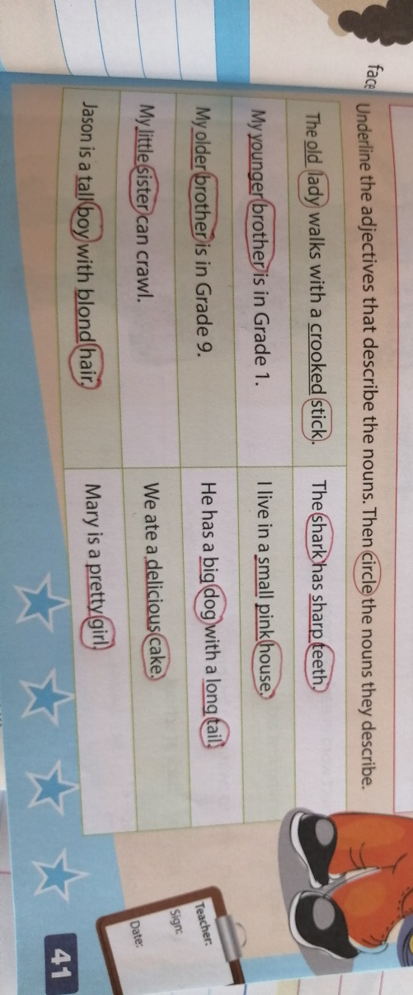
p 85- Pronouns, verbs, nouns, adjectives
xxx
____________________________________________________________________________

