Gr 6 First Additional Language
Term 2
English Language Workbook

S P E L L I N G

6.1 SPELLS FAMILIAR WORDS CORRECTLY, USING A PERSONAL DICTIONARY

Additional exercise
- Complete the Worksheet by underlining the correct spelled word.

6.2 WORDS STARTING WITH A “K-SOUND” AND FOLLOWED BY A, U OR O: USE A C TO SPELL THE WORD, E.G. CAN, COT, and CUT
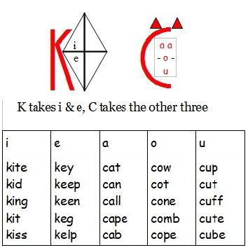

Yellow Book (DoE), p56
The soft and hard C sounds.
- Circle the sounds in different colours
- Write the words in the correct boxes.

Yellow Book (DoE), p67
The soft and hard C sounds.
- Compare the sounds of the words.

Yellow Book (DoE), p83
- Complete the Crossword Puzzle.

Additional exercise
- Add the correct letter to make a word.

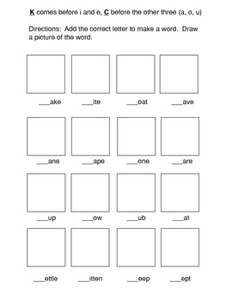

S P E L L I N G

7.1 USES THE DICTIONARY TO CHECK SPELLING AND MEANINGS OF WORDS

Activity 2(d), no1 (a-c), p59
- (a-c) Look up the meaning of the following words in a dictionary
- Orbit : ………………………………………………………………………………………………………………………..
- Earth : ………………………………………………………………………………………………………………………..
- Conclusions : ………………………………………………………………………………………………………………………..
- Invention : ………………………………………………………………………………………………………………………..

Yellow Book (DoE), p95
- Match the word with its meaning.

7.2 ADD –ES TO FORM PLURALS OF WORDS ENDING IN -S, -SH, -CH, OR –Z: E.G. BUNCH, BUNCHES; BRUSH, BRUSHES

Yellow Book (DoE), p91
- Plural Crossword puzzle.

Yellow Book (DoE), p100
- Fill in the correct plurals.

Additional Exercise
- Write the plural form of the nouns.

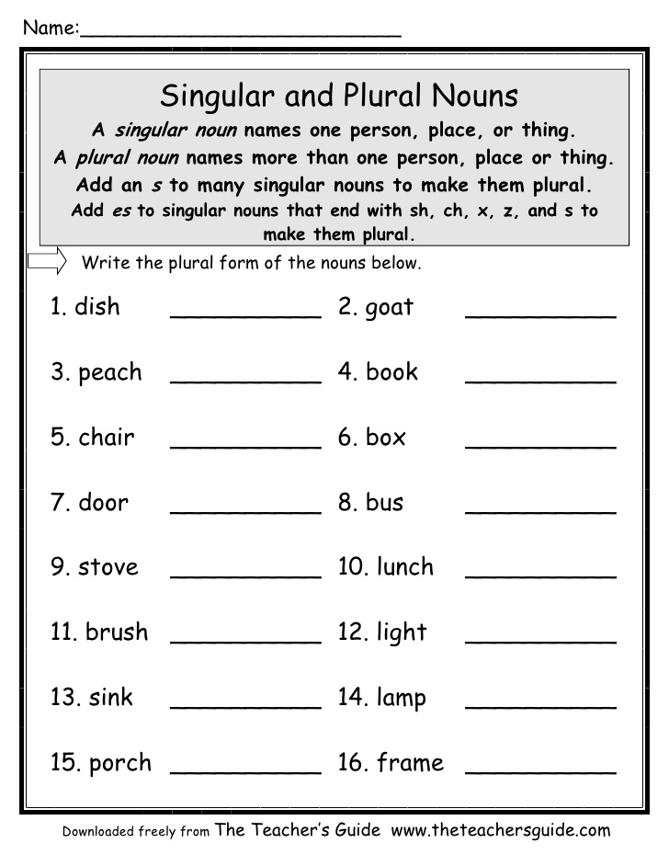

Additional Exercise
- Write the plural nouns from the word box to complete each sentence.

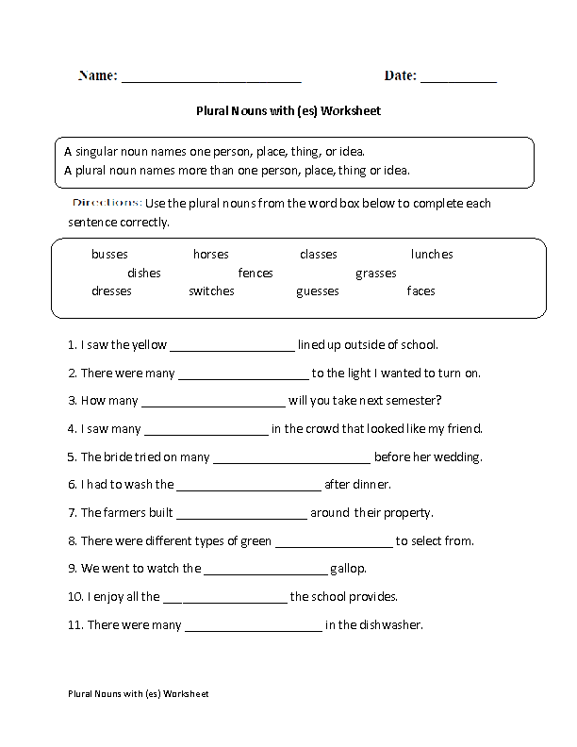

W O R K I N G W I T H W O R D S A N D S E N T E N C E S

6.3 UNDERSTANDS AND USES UNCOUNTABLE NOUNS (E.G. CHALK)

Rule, Yellow Book (DoE), p85

Additional exercise
      - Look at the pictures and find the uncountable nouns in the word search.
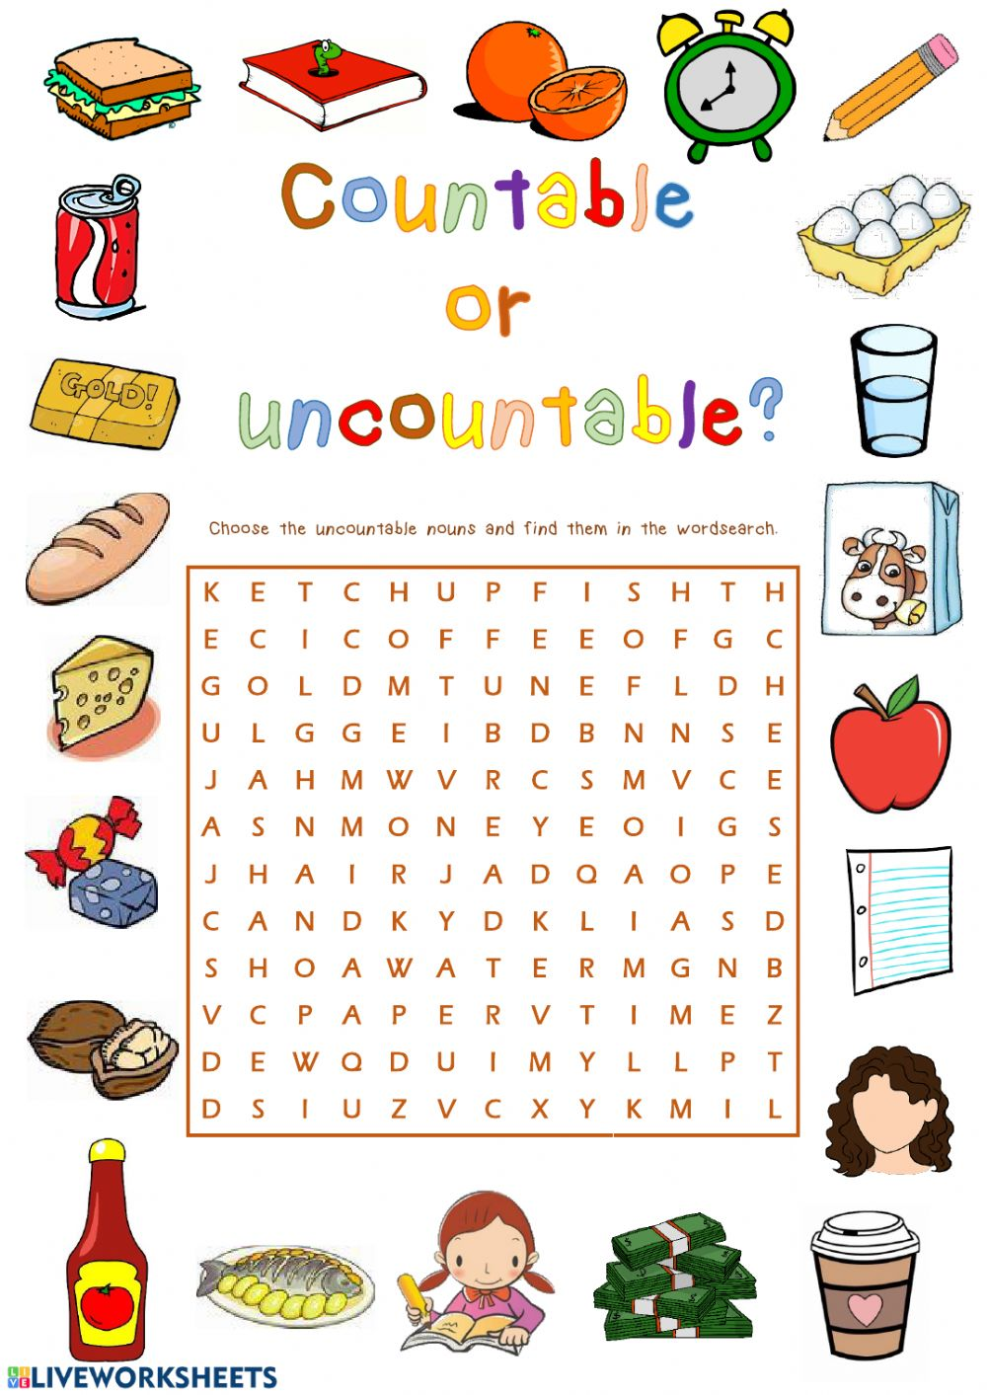

6.4 BUILDS ON USE OF DEMONSTRATIVE PRONOUNS (E.G. THIS, THAT, THOSE, THESE)

D E M O N S T R A T I V E P R O N O U N S
A demonstrative pronoun is a pronoun that is used to point to something specific within a sentence. These pronouns can indicate items in space or time, and they can be either singular or plural.

The following words are all Demonstrative Pronouns:
- Such
- This
- That
- These
- Those
- None
- Neither
Nouns are naming words and pronouns stand in the place of nouns. Demonstrative pronouns replace a noun, but also indicate where something is.

Rules for using this, that, these and those

 | Nearby | Further away
Singular | This | That
Plural | These | Those

An example is:
- This is mine. This implies nearby. These are mine (plural, nearby)
- That is yours. That implies further away. Those are yours (plural, further away)

Activity 2c (d), p15

Explain the different meaning of “this” and “these” in the following sentence: “We think this male is more than 50 years old but these crocodiles can live up to 100 years.”

Activity 5, p53

Use Demonstrative Pronouns (this / that / these / those) to complete the sentences.

………………….. is the place where the journey started.

………………….. are the poachers standing there.

………………….. over there is the rhino that was killed.

Look there. ………………….. are the learners who helped the Rhino Warriors.

Look here. ………………….. are the photos of the trip.

Activity 8, p135

Complete the following sentences with a demonstrative pronoun from the box:

this / that / these / those

………………….. story is about Simisani.

………………….. are his toys in the box over there.

………………….. here are the steps that Simisani sat on.

………………….. people walking there are the Abrahams family.

………………….. is the dog that made Simisani feel welcome. Here she is.

Yellow Book (DoE), p76
- Fill in either this, these, that or those to complete these sentences.

………………….. is my book.

………………….. are my books.

………………….. is my car in the car park across the road.

………………….. are cargo ships in the sea.

………………….. are my shoes.

………………….. cows in the next farm belong to the chief.

Yellow Book (DoE), p77
- Write your own sentences starting with these words.

Additional Exercise

Choose the best answer to complete each sentence
- ____________ was such an interesting experience.
  - That
  - These
  - Those
  - Such
- Are ___________ your shoes?
  - That
  - Them
  - Those
  - This
- You’ll have to get your own pen. ______________ is mine.
  - That
  - Those
  - Such
  - This
- There is no end to ___________.
  - Such
  - Those
  - This
  - None
- Because of their bad behaviour, ____________ of the children were given allowances.
  - None
  - That
  - Those
  - Them
- ____________ of them had seen it before.
  - Those
  - Neither
  - Such
  - This
- Is ____________ yours?
  - This
  - Those
  - These
  - Such
- Everyone ate early. When we arrived, ____________ was left.
  - That
  - Such
  - None
  - Neither
- Please give me one of ____________.
  - That
  - Those
  - This
  - Such
- ____________ are nice-looking.
  - This
  - That
  - These
  - Such

Additional Exercise

Choose the best answer to complete each sentence

1. ………… boys are in my class.
a) this
b) these
2. ………… apples are very sweet.
a) this
b) these
3. I like ………… colour.
a) this
b) these
4. Where shall we hang ………… pictures?
a) that
b) those
5. Can you help me carry ………… boxes?
a) this
b) these
6. Are ………… mangoes ripe?
a) this
b) these
7. ………… birds sing beautifully.
a) these
b) this
8. ………… were the best days of my life.
a) that
b) those
9. ………… was an interesting story.
a) that
b) this
10. Can you help me tie …………. knot?
a) this
b) these

6.5 BUILDS ON USE OF ADJECTIVES BEFORE NOUNS, E.G. THE SMALL DOG AND BEGINS TO USE THOSE THAT COME AFTER NOUNS, E.G. THE DOG IS SMALL.

Activity 2, p51
- Write the sentences by using another adjective in place of the underlined word.

Yellow Book (DoE), p82
- Fill in the adjective before the nouns in each of these phrases.

Small | Excellent | Pretty | Delicious | Thick | Little | Bright | Warm

The …………………………………………… dog.
The …………………………………………… dog.
The …………………………………………… cake.
The …………………………………………… girl.
The …………………………………………… soccer player.
The …………………………………………… book.
The …………………………………………… fish.
The …………………………………………… light.

6.6 BEGINS TO USE IRREGULAR FORMS OF SOME VERBS, E.G. RUN, RAN

I R R E G U L A R V E R B S

An irregular verb is one that does not form its simple past tense or its past participle by adding "-ed" or "-d" to the base form.
Regular Verb | Simple Past Test | Past Participle
jump | jumped | has jumped
Irregular Verb | Simple Past Test | Past Participle
arise | arose | arisen

Activity 9, page 55
  - Write the paragraph in the past tense
The ant-poaching unit …………………………. Geza. The rhino …………………………. so badly injured that he could not be ………………………….. The cameraman …………………………. to film when Geza …………………………. put down. William …………………………. his hand over Geza’s head while the young rhino’s body …………………………. still and peaceful.

Yellow Book (DoE), p110
  - Write the past tense of these words.

These are the most common fifty irregular verbs in the English language.

Rank | Base Form | Past Tense Form | Past Participle
1 | say | said | said
2 | make | made | made
3 | go | went | gone
4 | take | took | taken
5 | come | came | come
6 | see | saw | seen
7 | know | knew | known
8 | get | got | got/gotten (US)
9 | give | gave | given
10 | find | found | found
11 | think | thought | thought
12 | tell | told | told
13 | become | became | become
14 | show | showed | shown
15 | leave | left | left
16 | feel | felt | felt
17 | put | put | put
18 | bring | brought | brought
19 | begin | began | begun
20 | keep | kept | kept
21 | hold | held | held
22 | write | wrote | written
23 | stand | stood | stood
24 | hear | heard | heard
25 | let | let | let
26 | mean | meant | meant
27 | set | set | set
28 | meet | met | met
29 | run | ran | run
30 | pay | paid | paid
31 | sit | sat | sat
32 | speak | spoke | spoken
33 | lie | lay | lain
34 | lead | led | led
35 | read | read | read
36 | grow | grew | grown
37 | lose | lost | lost
38 | fall | fell | fallen
39 | send | sent | sent
40 | build | built | built
41 | understand | understood | understood
42 | draw | drew | drawn
43 | break | broke | broken
44 | spend | spent | spent
45 | cut | cut | cut
46 | rise | rose | risen
47 | drive | drove | driven
48 | buy | bought | bought
49 | wear | wore | worn
50 | choose | chose | chosen

6.7 BUILDS ON UNDERSTANDING AND USE OF SIMPLE PRESENT

Additional Exercise

Use the present simple tense answering the following questions.

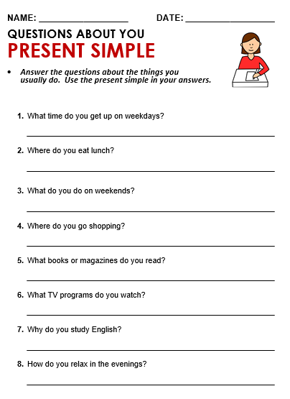

Additional Exercise

Complete the following worksheet.
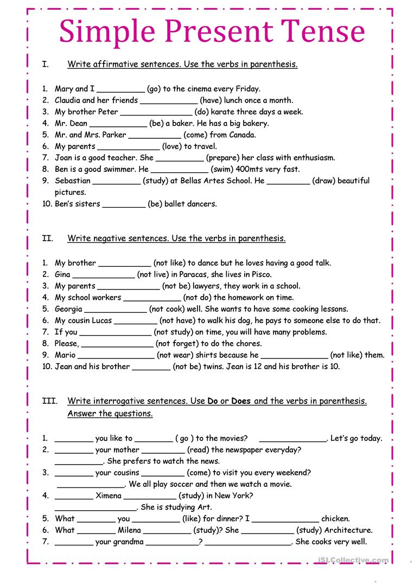

6.8 BEGINS TO USE ‘MUST’, ‘SHOULD’ AND ‘HAVE TO’ TO SHOW OBLIGATION.

M O D A L V E R B S (M U S T, H A V E TO, S H O U L D)

We can use have to + infinitive, must + infinitive and should + infinitive to express obligation (something you have to do).
Present | Positive | Negative
have to /  don't have to | strong obligation  (possibly from outside)  - Children have to go to school. | no obligation  - I don't have to work on Sundays.  - You don't have to eat anything you don't like.
must / mustn't | strong obligation  (possibly based on the speaker's opinion)  - I must study today. | negative obligation  - You mustn't smoke here.
should / shouldn't | mild obligation or advice  - You should save some money. | mild negative obligation or advice  - You shouldn't smoke so much.
Be careful about the difference between mustn't and don't have to!
Mustn't means it's not allowed, or it's a bad idea:
- You mustn't eat so much chocolate, you'll be sick
Don't have to means you don't need to do something, but it's fine if you want to do it:
- I don't have to get up early at the weekend (of course, if I want to get up early, that's fine, but I can stay in bed if I want).

Activity 6, page 53
- Practise using must, should and have
- I ……………………… do my homework.
- I ……………………… go to school.
- I ……………………… speak nicely to my little brother.

Yellow Book (DoE), p126
- Complete these sentences.

Additional Exercise
- Write the missing word in each sentence. Choose from the modal verbs in the box below.
will | must | should | can | may | could | might

1. You _______________ borrow the books in this section of the library.
2. To apply for financial aid, you _______________ fill out an application form.
3. We _______________ need to get some milk on the way home.
4. Students _______________ stay home if they have the flu.
5. You _______________ leave your coats on the bed in the other room.
6. You _______________ clean up your room before you go outside.
7. He _______________ take a biology class in the spring.
8. I think you _______________ wear your blue shirt with those pants.
9. You _______________ fix those shoes with some shoe glue.
10. You _______________ want to try on some of the salad.
11. You _______________ check to see if that book is available on-line.
12. You _______________ make a copy of this document.
13. You _______________ be nice to your little brother.
14. You _______________ have automobile insurance to drive a car in California.

Additional Exercise
- Write the words in the correct order to make sentences.

- You anyone tell mustn’t!
....................................................................................................................................................
- have We early be there to
....................................................................................................................................................
- call remember I Dad to must
....................................................................................................................................................
- don’t to pay have You
....................................................................................................................................................
- fruit ! salad should try this You
....................................................................................................................................................
- class You late mustn’t for be
....................................................................................................................................................
- trainers get new should some You
....................................................................................................................................................
- to You eat don’t all have it
....................................................................................................................................................
- it shouldn’t about worry He
....................................................................................................................................................

7.3 USES NOUNS THAT HAVE ONLY PLURALS, E.G. SCISSORS AND TROUSERS

N O U N S T H A T O N L Y H A V E A P L U R A L F O R M

There is a small group of nouns that exist only in the plural form, for example:
- clothes, pants, scissors, shorts, thanks, trousers

These nouns do not exist in the singular form and are usually described as "PLURAL-ONLY NOUNS".

We use them with plural verbs and plural pronouns, for example:
- My trousers are dirty. I need to wash them.
We cannot use them with numbers.

Plural-Only Nouns with Two Parts
Many plural-only nouns are tools or items of clothing that have two parts (like trousers, which have two legs).

Clothing
- panties, boxers, briefs, tights
- jeans, pants, pyjamas, shorts, trousers

Tools
- headphones
- pliers, scissors, tongs, tweezers
- binoculars, glasses, goggles, Ray Bans, sunglasses

= pair of, because the above examples have two parts, we can refer to them as "pair of" or "pairs of" to quantify them.
To talk about one item we can say a pair of, one pair of, my pair of, this pair of etc. To specify more than one item we can say two pairs of, three pairs of etc.
- I need a new pair of sunglasses.
- You can get rid of that old pair of headphones.
- I'd like to buy one pair of boxers and two pairs of jeans.

Some nouns may be plural-only with one meaning and singular/plural with other meanings. For example, the plural-only noun glasses means a pair of lenses that we wear to help us see better. Do not confuse with the words:
- Glass, glasses (countable noun): a container for drinking from. I'd like two glasses of orange juice please.
- Glass (uncountable noun): transparent material used for windows, screens etc. Be careful not to break the glass.

Other Plural-Only Nouns
- earnings
- belongings, clothes
- congratulations, thanks
- outskirts, premises, surroundings

In these example sentences notice the use of plural verbs and plural pronouns:
- Make sure your belongings are tagged with your name before you check them in.
- Her thanks were clearly sincere.
- If your clothes are wet you can dry them upstairs.
- The outskirts of Washington are really pretty and they stretch for miles.

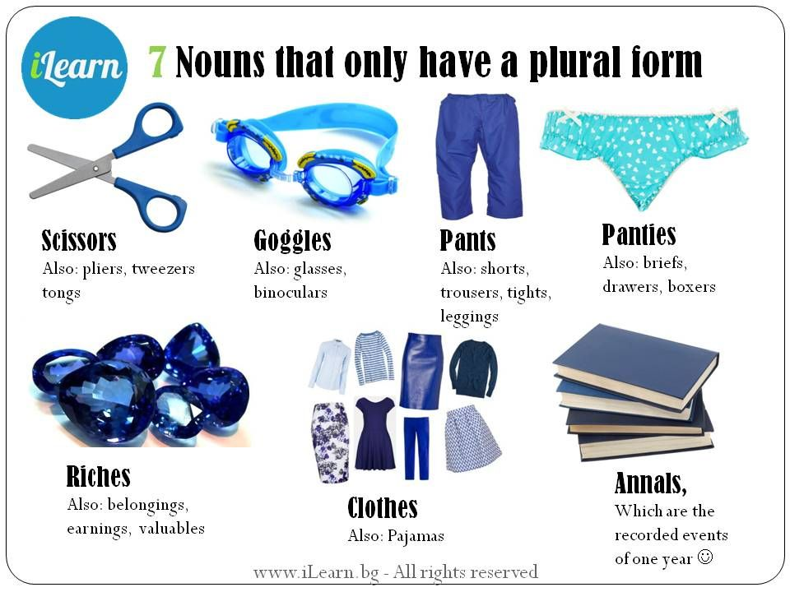

Yellow Book (DoE), p91
- Plural looking nouns.

Yellow Book (DoE), p100
- Fill in the correct plurals.

Additional Exercise
- Choose the correct option to complete the sentence.
1. I lost my scissors. Have you seen _______?
it
them
2. _______ your belongings?
Is that
Are those
3. I need a _______ glasses to protect my eyes.
pair of
couple of
4. Her clothes _______ you really well.
fit
fits

7.4 BEGINS TO USE POSSESSIVE PRONOUNS (E.G. MINE, YOURS, HIS, HERS, OURS, THEIRS)

P O S S E S S I V E P R O N O U N S

Possessive pronouns include my, mine, our, ours, its, his, her, hers, their, theirs, your and yours. These are all words that demonstrate ownership. ...
Possessive pronouns show that something belongs to someone. The possessive pronouns are my, our, your, his, her, its, and their. There’s also an “independent” form of each of these pronouns: mine, ours, yours, his, hers, its, and theirs. Possessive pronouns are never spelled with apostrophes.
Possessive pronouns simplify constructions that show possession of a noun.
- Jane takes pride in Jane’s outfits.
It sounds odd to use Jane’s name twice in this sentence. A possessive pronoun solves the problem:
- Jane takes pride in her outfits.

Yellow Book (DoE), p92
- Fill in the correct pronouns in each of these sentences.

Yellow Book (DoE), p93
- Write sentences using each of these possessive pronouns.

Yellow Book (DoE), p101
- Fill in the correct pronouns.
Additional Exercise
- Complete the following Worksheet.

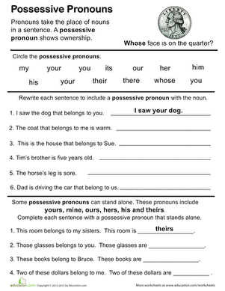
Additional Exercise
- Complete the following Worksheet.

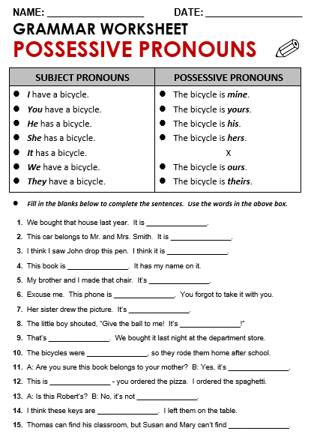
7.5 BEGINS TO USE ADJECTIVES THAT COME AFTER NOUNS E.G. THE DOG IS SMALL.

Activity 6, page 62
- (1&2) Underline all the adjectives in the paragraphs.
Most space trips take astronauts to the Space Station for two weeks. Frank de Winne, a Belgian astronaut, did a six-month trip last year. “Things that is difficult in the short term, such as not having a nice shower or any fresh fruit, become part of normal life. The things you really miss are close contact with your wife, your kids and your friends,” he says.

For those who built and lived in the faraway space station, seeing its bright light shooting across the sky at night causes strong feelings few others will understand. “You can go out on a quiet night and see the thing flying over and you think, I was there, I helped put that together,” says Sellers, another astronaut who stayed on the space station.

Chapter 8, Activity 2(c), no3, p69
- Fill in the nouns and adjectives to describe what the children saw on their outing.
mussel
orange
sea urchin

Additional Exercise
- Complete the following Worksheet

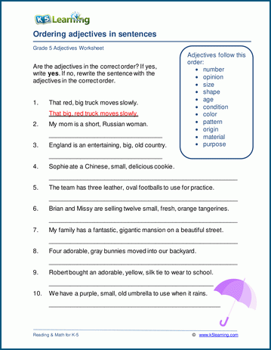

7.6 BUILDS ON UNDERSTANDING AND USE OF COMPARATIVE AND SUPERLATIVE ADJECTIVES

D E G R E E S O F C O M P A R I S O N

A comparative adjective is used to compare two things.

A superlative adjective is used when you compare three or more things

Activity 7, page 63
  - Rewrite the paragraph below using the correct word in brackets.
The Earth is ……………………. to the Sun than Mars. The planets that are ……………………. the Sun are ……………………. than the planets that are …………………….. Neptune is the …………………….planet and Mercury is the ……………………. planet in the solar system. The …………………….planet is Jupiter. The second ……………………. planet is Saturn. The …………………….planet is Mercury.

Additional Exercise
  - Please write the correct form of the adjective.
- Timmy is (young) ……………………………….. than his brother.
- Sheila ran (fast) ……………………………….. than I did.
- Tom is (angry) ……………………………….. than his boss about the situation.
- The book is (slow) ……………………………….. than the movie.
- The weather is (hot) ……………………………….. today than yesterday.
- Jeff is the (big) ……………………………….. football player on the team.
- Tom is the (happy) ……………………………….. of all the students.
- The puppy was the (fat) ……………………………….. one in the litter.
- Bess lost weight and is the (thin) ……………………………….. woman in the room.
- Tom has the (red) ……………………………….. hair I have ever seen.
- Ted is (handsome) ……………………………….. than his father.
- The book is (exciting) ……………………………….. than the movie.
- She seems (sympathetic) ……………………………….. than her friend.
- Brent wrote the (interesting) ……………………………….. essay of the two.
- Of the two assistants, Roxanne seems (competent) ………………………………...
- This is the (accurate) ……………………………….. story I have ever read.
- Of all the chefs, Todd made the (delicious) ……………………………….. cake.
- He has the (vicious) ……………………………….. dog in the neighbourhood.

Additional Exercise
  - Complete the sentences with the correct adjective.

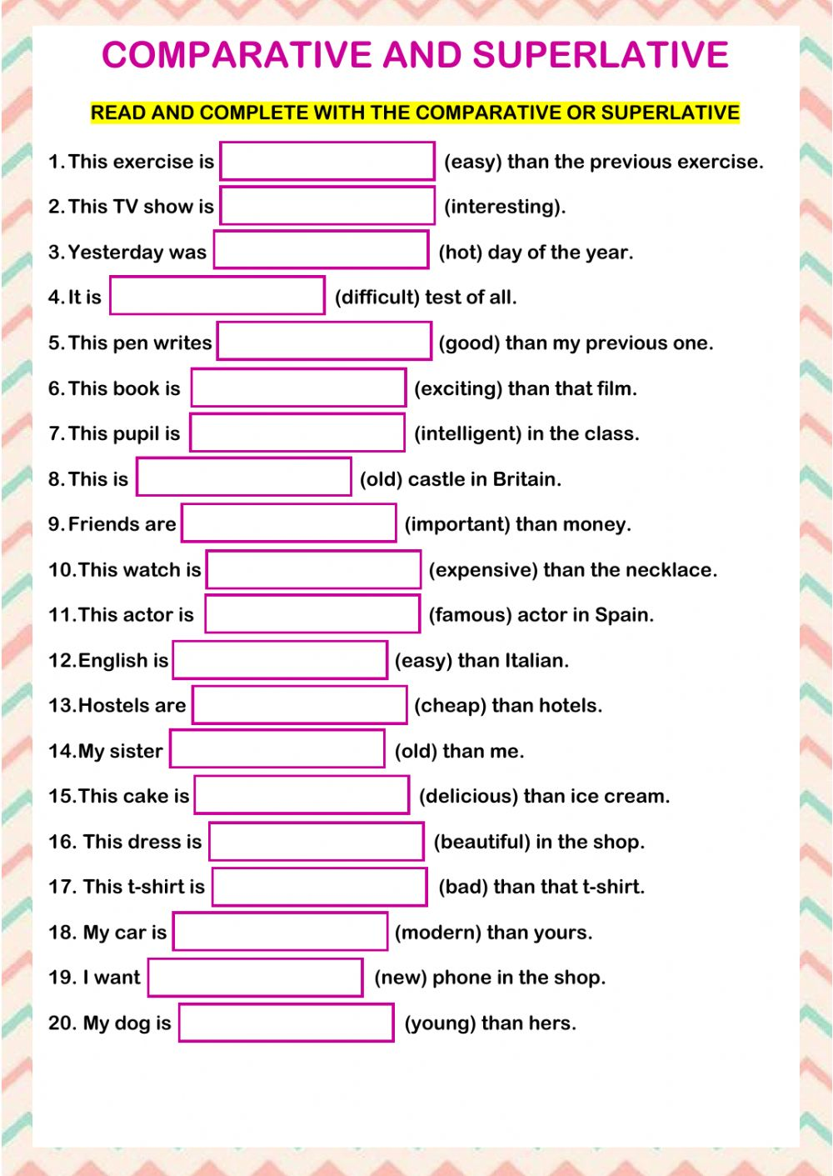
7.7 USES ADVERBS OF MANNER (E.G. QUICKLY, SLOWLY)

A D V E R B S O F M A N N E R

- In English grammar, an adverb of manner is an adverb (such as quickly or slowly) that describes how and in what way an action, denoted by a verb, is carried out.
- These adverbs are also called manner adverbs or manner adverbials
- Adverbs of manner describe how something happens.

For example, it is possible to walk or run at different speeds. The words used to describe walking or running at different speeds (quickly or slowly for example) are excellent examples of adverbs of manner.
- The boys ran.
(There is no adverb of manner in this sentence, so we can only imagine how fast the boys are running.)
- The boys ran quickly.
(The adverb of manner is quickly. It tells us that the boys are in a hurry.)
- The boys were tired, so they ran more slowly than before.
(The adverb of manner is slowly. It tells us that the boys are running, but they aren’t covering as much ground as they were before.)
There are a few rules to remember regarding adverbs of manner:
- When using these adverbs, be careful not to place them between the object and the verb. They often fit best after the sentence’s object or main verb.
- If there is a preposition before the object, the adverb of manner may be placed either before the preposition or after the sentence’s object.
- Add emphasis by placing an adverb of manner before both the verb and object, and when these adverbs are placed at the beginning of a sentence, they catch the reader’s attention.
As you read the following examples of adverbs of manner, you will notice how the same adverb can lend different meanings to sentences containing nearly the exact same set of words.
- He quickly agreed to go to the store for milk. (His agreement was quick)
- He agreed to go to the store for milk quickly. (He would go to the store quickly)
- She quietly asked me to leave the room. (Her request was quiet)
- She asked me to leave the room quietly. (I am not going to make noise when I leave)
- The doctor woke the gently sleeping patient. (The patient was sleeping gently)
- The doctor gently woke the sleeping patient. (The doctor was gentle while waking the patient)

Yellow Book (DoE), p101
- Fill in appropriate adverbs.

Additional Exercises
- The following exercises will help you gain greater understanding about how adverbs of manner work. Choose the best answer to complete each sentence.

1. The excited baby pounded the table _______________.
a. Badly
b. Hungrily
c. Normally
d. Variously
2. Walk ______________ or you may miss the bus.
a. Quickly
b. Slowly
c. Personally
d. Happily
3. Reading ______________ helps you to understand concepts better.
a. Rapidly
b. Briefly
c. Carefully
d. Always

4. Playing music too _______________ can damage your hearing.
a. Slowly
b. Cheerfully
c. Carelessly
d. Loudly
5. A tortoise walks _______________.
a. Mostly
b. Slowly
c. Happily
d. Eagerly

Additional exercise
- Please make adverbs from the adjective in brackets.
- My parents were ………………………. (happy) married.
- He ………………………. (happy) looked through the magazine.
- They watched the football match ………………………. (happy)
- She spoke ………………………. (happy) and ………………………. (happy) at the directors’ meeting.
- Drive ………………………. (happy) here – the road is wet.
- My friend answered ………………………. (happy). “Now look here, buddy, you are wrong.
- She walked up to her husband and ………………………. (happy) patted him on the shoulder.
- He talks so ………………………. (happy) that I can’t follow him!

7.8 DEVELOPS UNDERSTANDING AND USE OF CONNECTING WORDS SHOWING ADDITION, SEQUENCE AND CONTRAST.

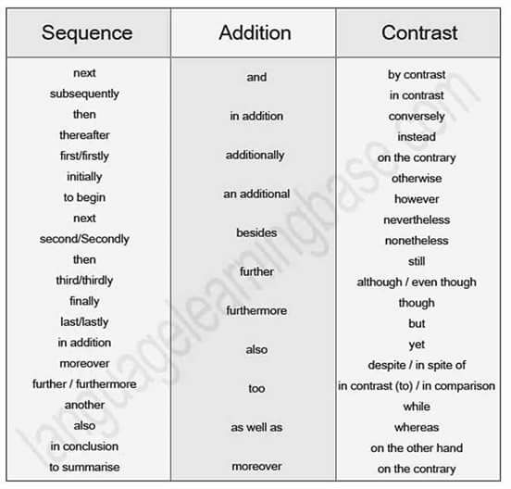

Activity 4, page 61
  - Join the following ten sentences to make a paragraph that has three or four sentences. Use connecting words, for example: which, that, and, but, then
There are billions of stars in the universe ……………………… are made up of gas and dust ……………………… which grow in size over billions of years. Planets orbit or go round stars ……………………… our sun ……………………… is only a medium sized star that has eight planets ……………………… the earth orbiting it. Moons orbit around planets and the earth has one moon ……………………… Jupiter has nine.

Additional exercise
  - Complete these sentences with the correct conjunction.
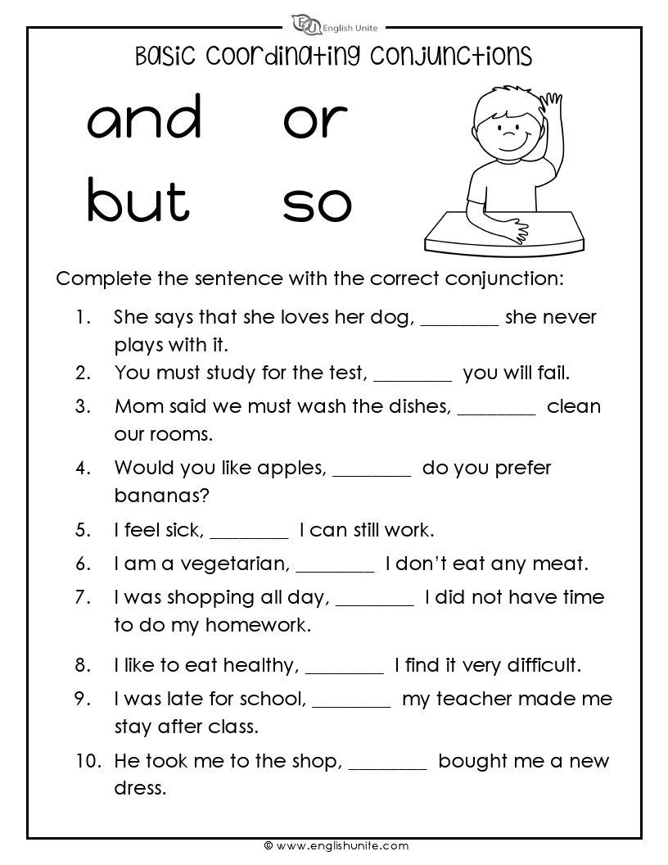

Additional exercise
  - Join the two pairs of the sentences.
