**Woensdag 12 Aug**

**E**

**T**

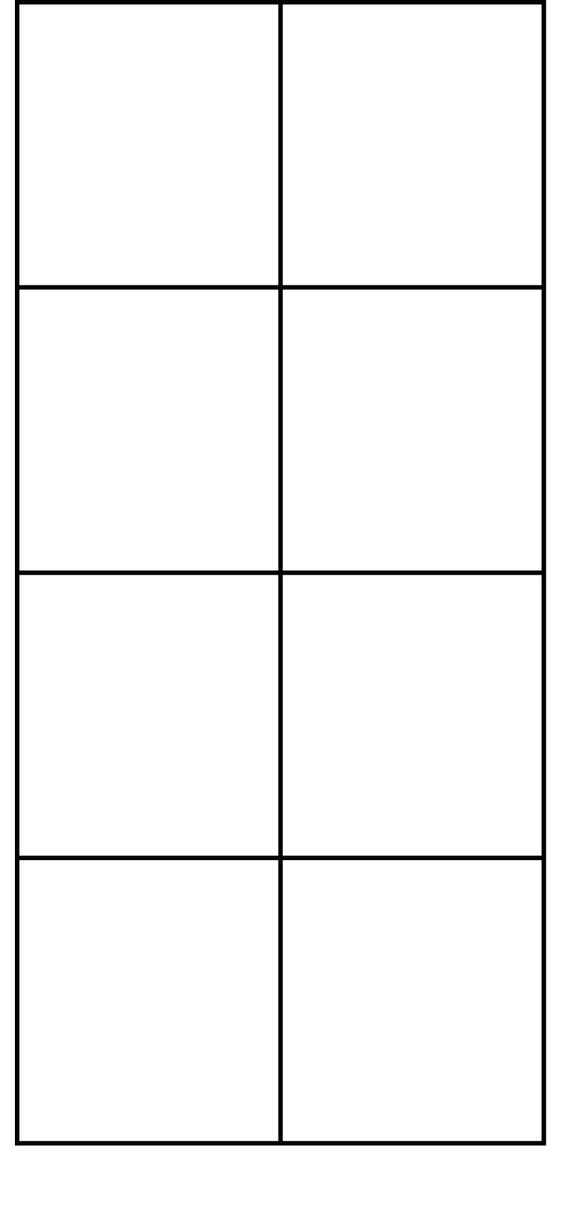

**+**

**E**

**T**



**+**

3v

5

4v

3

3v

3

2

2

3v

**=**

**=**

**E**

**T**



**+**

**E**

**T**



**+**

8

7

6

5

1

2

2

1

**=**

**=**

**E**

**T**



**+**

**E**

**T**



**+**

8

4

7

6

5

1

2

3

**=**

**=**

Woensdag 12 Aug.

Begripslees: Vier vriende.

1. Watter vier vriende sit bymekaar onder ‘n doringbos?
2. Waarom voel die maats so treurig?
3. Watter plan het die vier vriende beraam?
4. Wanneer het die vier vriende na die boer se tuin toe gegaan?
5. Waarom dink jy bly Bokkie buite die tuin?
6. Hoe het Hasie by die boer se tuin gekom?
7. Wie grawe die wortels los?
8. Wie trek die wortels uit?
9. Wat het die boer met Hasie gedoen? Die boer het hom…..
10. Hoekom was Skilpad nog nie daar nie?

Wednesday 12 Aug.

Sam the seal.

“Achooo!” Ed sneezed through his snout. He did not know he should cover his mouth. And Sam got wet, which he did not like. “Can I please have a towel so that I wipe...” But his words were lost as Ella screamed, “dad, oh, dad you bought ice cream!”

“Sam” said Ella, “you must have a bite...” and the spoon, by accident, smacked his eye. Sam wiggled away and covered his face. How was he going to get out of this place? But before he could run, Ella picked him up. “Sam” she said, “have a drink from my cup.” Then she put him down, on top of a ball. “Whoa!” said Sam as he tried not to fall. “Look, dad, isn’t Sam cute?” But Ed was busy removing his boots. Bam! The boots landed on, Sam knocking him over and into the sand. Sam grabbed a towel and slipped underneath, hoping that Ella and Ed wouldn’t see.