Week 1  12, 14& 16  OCT 2020 | TOPIC: POEMS

In class:
- Language – Figure of Speech
- Listening and Speaking – Listens to a poem
- Reading – Reads a poem

Work in Red Book:
Page | Work | Learners
1 | Figure of Speech | Discuss and do in class
2 | Complex and Compound Sentences | Discuss and do in class
3 | Activity 1 – Listens to a poem | Discuss and do in class
4 | Activity 9b, p111 | Discuss and do in class
5 | Activity 2d, p43 | Read and do for homework

----------------------------------------------------------------------------------------------------------------------------------------------

Week 2  20 & 22  OCT 2020 | TOPIC: POEMS

In class:
- Writing - Planning a Poem
- Writing - Writing a Poem

Work in Red Book:
Page | Work | Learners
6 | How to write a poem | Write from the board and do
7 | Draft | Homework
8 | Final | Homework

----------------------------------------------------------------------------------------------------------------------------------------------

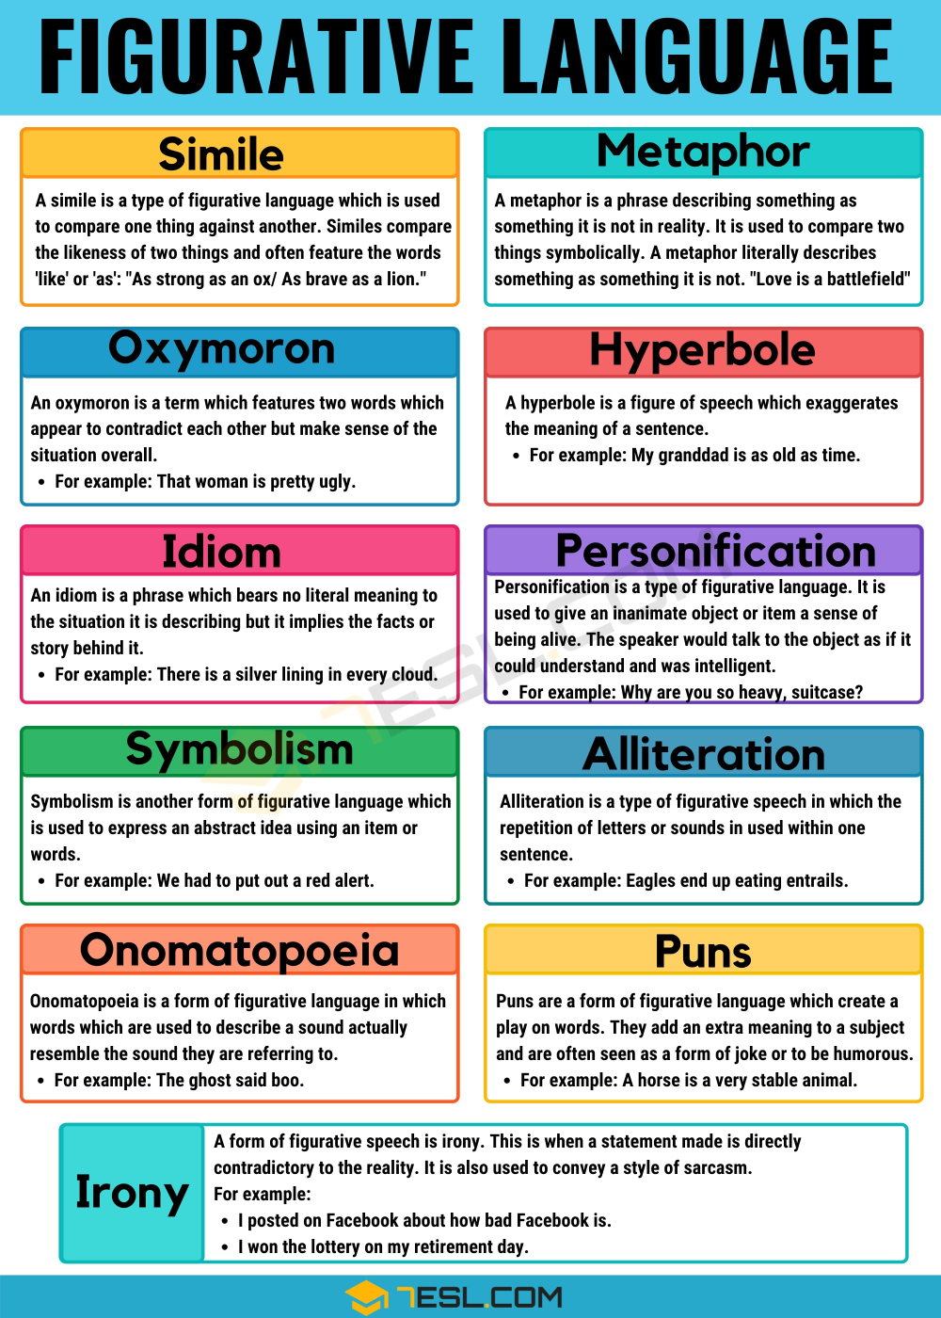

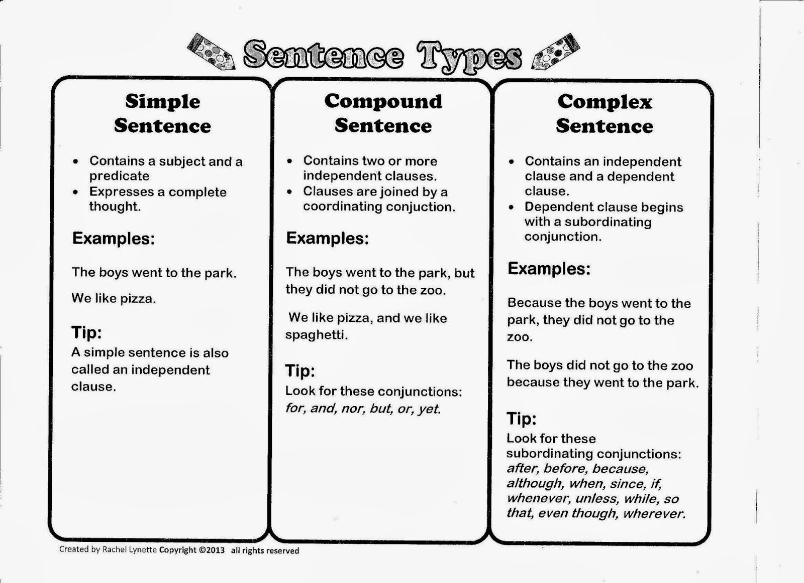

----------------------------------------------------------------------------------------------------------------------------------------------

Activity 1, Page 41

- Describe the main idea or facts of what you heard.
The poet is trying to make people think about our senses of hearing and seeing.

2a What is the poet telling us in the poem?
He sees poetry in sounds and sights.

2 b Name two sounds that are mentioned.
He mentions a few sounds:
a whisper, a shout, a laugh, a sigh, and an echo.

2c. Name two objects that are mentioned.
The poet mentions a moon and a star.

3a. What is the main idea of the poem?
To tell you about different colours.

3b. How does the poet describe different colours?
red and rose blue and sky
white and snow yellow and sun
green and grass orange and orange
----------------------------------------------------------------------------------------------------------------------------------------------

Activity 9b, Page 111
“My best friend”

- What is the poem about?
The main idea of the poem is to describe the poet's best friend.

- How does it make you feel?
(warm, happy, wishful, grateful)

- Which words rhyme?
day/away
sunny/funny
true/you
you/dew

----------------------------------------------------------------------------------------------------------------------------------------------

- WHO?
Both in gr6 / Family
7 years

(4) LIKES/DISLIKES?
Sport / Chips / Movie

(2) LOOKS?
Brown hair / Green eyes
Nice smile

(5) REASON?
My best friend / Naughty / together
Always friendly
Honest
(3) PERSONALITY?
S U Z I E
16 October 2020

Activity 9c, Page 111

- What two things does the writer say her friend is like?
Her friend is like the sun and the dew.

- What other way could we describe a sunny person?
cheerful, happy, warm, giving

- What are the dark clouds that the writer’s friend chases away?
The dark clouds are sadness.

- What adjectives would you use to describe the writer’s friend?
smiley, happy, kind, brave, courageous, loyal, amusing, soft, caring

- How does the writer feel about her friend?
The writer likes her friend very much. She is very grateful to have such a good friend.

- Why do you think the writer uses rhyming words and longer and shorter lines?
Rhyming words make the poem flow nicely. Lines of differing length keep the reader interested.

----------------------------------------------------------------------------------------------------------------------------------------------

Activity 2d, page 43

- What is the main idea of the poem?
The main idea is that a blind boy uses all his senses to describe colours.

- (a) What two things are being compared to each other?
Green, a sight experience, is compared with a rustle, a hearing experience.

- (b) Is it a simile or a metaphor? Explain your answer.
It is a simile because the word “like” is used in the comparison.

2. (c) Do you think it is a good comparison? Why or why not?
Yes, it is a good comparison because green is a fresh, crisp, cool colour. Rustle is a crisp word, the forest is green and shady, cool, and the wind is fresh.

- What does the boy compare the colour blue to?
Running water

- What colour is described as loud? Do you agree with the poet? Why or why not?
- Red is compared to a trumpet sound.
Yes, I agree. Bright red can be a strong colour.
Or
- Purple is compared to a thunderstorm.
Yes, I agree. Purple can be a striking colour.

- Which of the five senses does the boy use to describe the colours?
Hearing | Green is like a rustle / Red is like a trumpet sound / Purple must be like a thunderstorm / White is a pleasant stillness
Feeling | Yellow is something soft and warm
Sound | Running water, that is blue
Smell | Pink is like the smell of roses

- Name one object that is “warm & yellow”?
Warm and yellow could describe a ginger kitten, a baby chicken, or the sun.

- Write a simile to describe the colour black.
As black as tar; coal; night

https://examples.yourdictionary.com/simile-examples-for-kids.html

Simile Examples for Kids
A simile is a figure of speech that directly compares two different things. The simile is usually in a phrase that begins with the words "as" or "like." This is different from a metaphor, which is also a comparison but one says something is something else.
Hopefully, these simile examples for kids will get them excited about reading and writing.

Simile Examples Using As
In this similes list the phrases use the format "as something as something else" to make a comparison:
As American as apple pie | As big as an elephant
As black as coal | As blind as a bat
As boring as watching paint dry | As brave as a lion
As busy as a bee | As cheap as dirt
As clean as a whistle | As clear as mud
As clear as crystal | As cold as ice
As cool as a cucumber | As cunning as a fox
As dead as a doornail | As deaf as a post
As difficult as nailing jelly to a tree | As dry as a bone
As dull as dishwater | As easy as ABC
As fit as a fiddle | As flat as a pancake
As free as a bird | As fresh as a daisy
As gentle as a lamb | As good as gold
As hard as nails | As heavy as lead
As helpless as a baby | As honest as the day is long
As hot as blue blazes | As hungry as a bear
As innocent as a lamb | As large as life
As light as a feather | As long as a month of Sundays
As loose as a goose | As mad as a hatter
As mad as a hornet | As old as the hills
As pale as death | As plain as the nose on your face
As playful as a kitten | As pleased as punch
As proud as a peacock | As quick as lightning
As quiet as a church mouse | As regular as clockwork
As scarce as hen's teeth | As sharp as a razor
As sick as a dog | As silent as the grave
As slippery as an eel | As slow as molasses
As smooth as a baby's bottom | As snug as a bug in a rug
As solid as the ground we stand on | As sour as vinegar
As stiff as a board | As straight as an arrow
As strong as an ox | As stubborn as a mule
As sturdy as an oak | As sweet as pie
As tall as a giraffe | As tough as old boots
As useless as a chocolate teapot | As warm as toast
As white as snow | As wise as an owl

Simile Examples Using Like
These similes compare using the format "something like something else:"
Sing like an angel | Act like an animal
Eat like a bird | Fight like cats and dogs
Work like a dog | Work like a dream
Soar like an eagle | Sound like fingernails on a chalkboard
Swim like a fish | Racing like a scared bunny
Have eyes like a hawk | Eat like a horse
Sleep like a log | Gravitate like a moth to the flame
Eat like a pig | Smell like a rose
Sound like a screaming baby | Shine like the stars
Meander like a stream | Exploded like a volcano

Simile Sentence Examples
Did you have any favourites from the similes lists above? Let us pull out a few and see how similes can make our writing more interesting and colourful.
- During the house fire, my Dad was as brave as a lion.
- Sunday is cleaning day. By the time we are done, the house is as clean as a whistle.
- That teacher was as dull as dishwater.
- I think my grandfather is as old as these hills!
- This house of cards is as sturdy as an oak.
- My best friend sings like an angel.
- After I received that "A" on my spelling test, I thought I might soar like an eagle.
- Gah! Her voice sounds like nails on a chalkboard!
- In our eighth-grade pageant, we shone like stars.
- This path meanders like a stream.

Writing a poem

P L A N N I N G

- Close your eyes and imagine you are with your friend.
- What can you see, hear, taste, touch, or smell?
- What colours are there?
- What are you feeling inside?
- What are you wearing?
- Open your eyes and quickly write down whatever words or phrases came into your mind.
- Do not worry about spelling.
- When you have your list, underline the words and phrases that are the most exciting and original for you.

D R A F T

Now write a poem entitled “My Best Friend”, describing the things you never want to forget.

- Use alliteration, assonance, metaphors, and similes to bring your poem to life.
- Use rhythm, but do not try to force things to rhyme.
- It is more important to get a musical rhythm and lively descriptions.
- Final check for spelling and punctuation.

F I N A L

- Write your poem out neatly.

